**FACULTY OF ENGINEERING AND TECHNOLOGY**

**SCHOOL OF COMPUTING**

**DEPARTMENT OF COMPUTING TECHNOLOGIES**

**AY 2023- 24 EVEN**

**18CSE352T NEURO-FUZZY AND GENETIC PROGRAMMING**

**Simple Interactive Learning Demo on Topic**

**Topic Choice: Artificial Neural Networks**



**TEAM MEMBERS**

1. RA2111003010380 - HARSHA MALLA
2. RA2111003010437 - SAI SAKETH
3. RA2111003010444 - SHREY RATHORE

**Objective: To make students understand various aspects of neural networks, including the fundamental units of computation, different models and architectures, activation functions, learning rules, and algorithms used in artificial neural networks. It also touches on specific types of neural networks like Perceptron, MADALINE, and Radial Basis Function Neural Networks, and their primary uses. Additionally, it includes questions on common problems faced during the training of neural networks. Overall, it’s a comprehensive quiz on the basics of artificial neural networks.**

**Software Used:** [**https://www.slido.com/**](https://www.slido.com/)

**Screen Shots:**



[**https://app.sli.do/event/7c9J75oMtGgMtGXyn6BAby**](https://app.sli.do/event/7c9J75oMtGgMtGXyn6BAby)

**We have created a live quiz taking platform for the topic neural network   
This quiz can only be given by student to whom we share the qr code or link   
the first page the students see will be a multiple choice question with 4 options and a 10 sec timer to answer it.**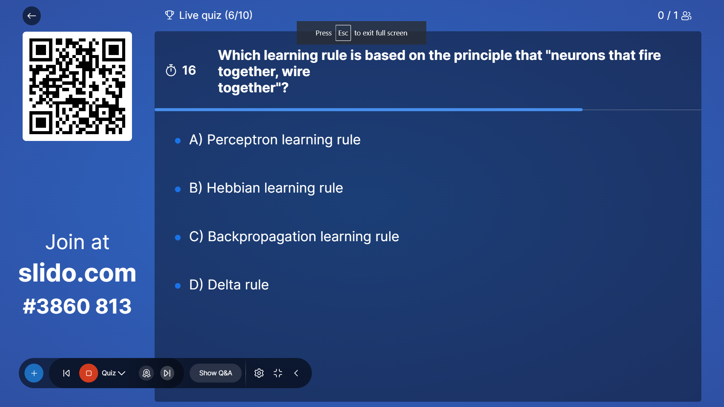

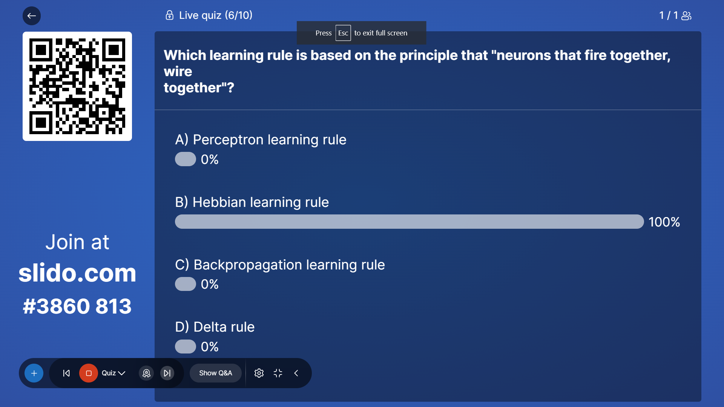

**The next picture shows a poll presentation of the answers that were chosen by the student which gives us an understanding of how many students the topic is clear to and how many are still struggling.**



**The next picture shows which option is correct and also highlights the poll which is correct to green in color which helps students understand which answer is correct and also what their chosen option was.**

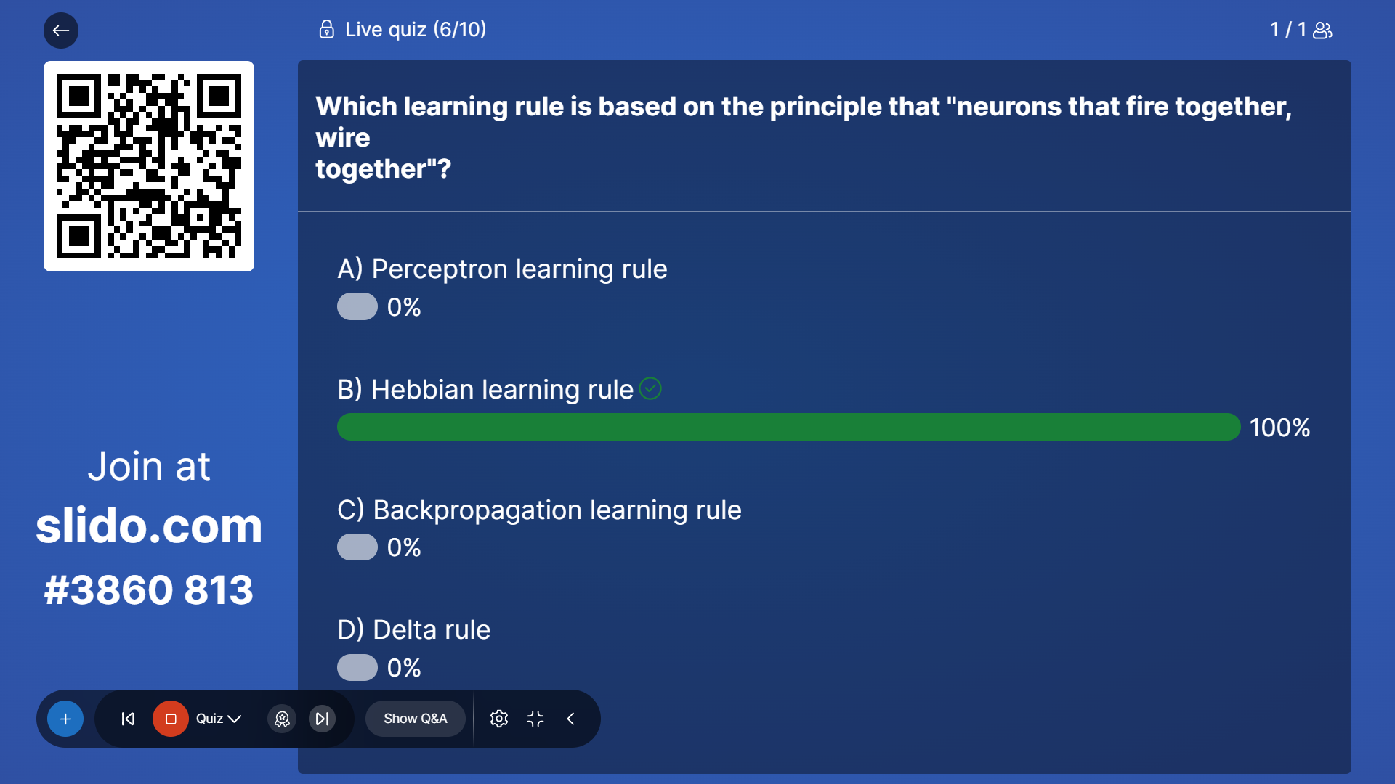

**The next picture is depicting a leadership board to applaud and celebrate the winner and also given context of total correct questions bagged by each and every student.**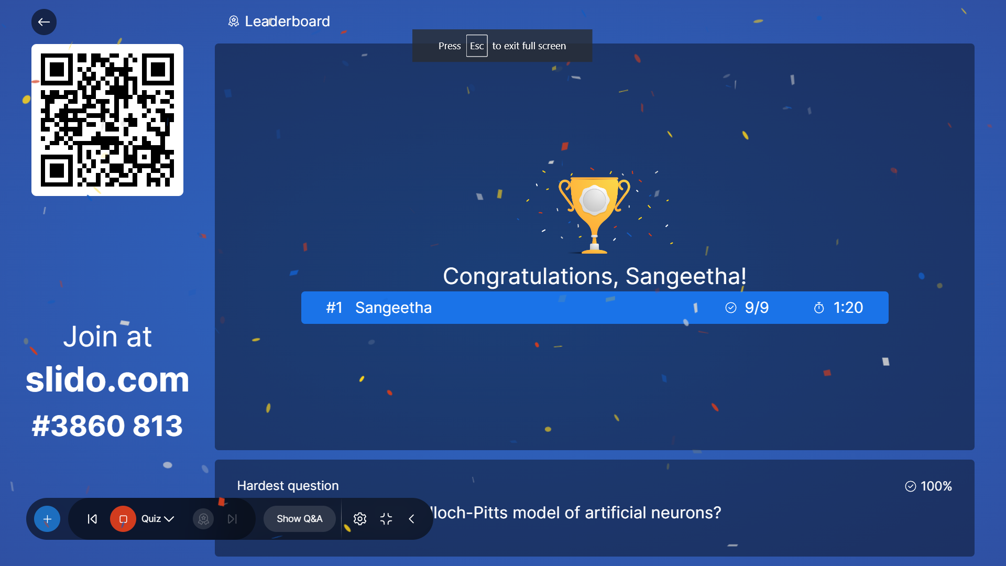

**Video Link (Make it Public):**

**GitHub Link(Make it Public):** [**https://github.com/Shreyrath0re/nuerofuzzy**](https://github.com/Shreyrath0re/nuerofuzzy)

**Contribution of Each Members:**

**Sai Saketh came up with the topic that we have used as our quiz topic and he and Harsha Malla came up with the sites and questions that we can use to make the interactive quiz and Shrey Rathore finally made the quiz and demonstrated to make this report and github link.**